The Plant Schematic is prepared as part of the Basic Product Information that is used when implementing a HACCP program. The points of cross-contamination should be marked on the plant schematic and a full description of each of the identified hazards should be recorded on the hazard analysis form and, where appropriate Form 10 .

The plant schematic is specific to each HUB. HUB users will also prepare a plant schematic for their food safety plan identifying their movements through the facility.

The plant schematic is a useful tool for identifying potential areas of cross contamination. Cross contamination risks include raw and allergenic ingredients, waste and areas where employees could cross contaminate product through mishandling.

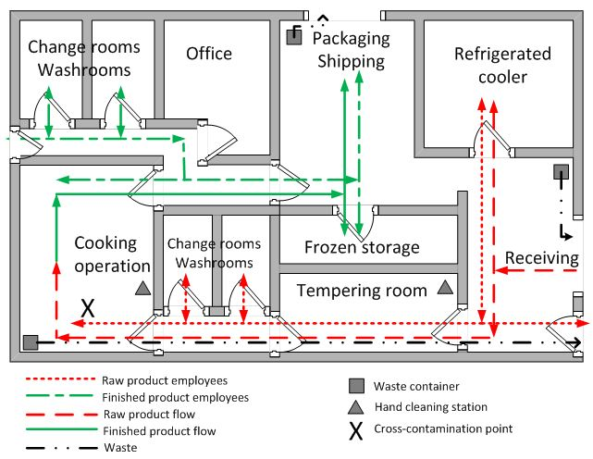The diagram below is from the CFIA website and highlights the flow of people and materials throughout the facility. (<https://inspection.canada.ca/preventive-controls/preventive-control-plans/domestic-food-businesses/eng/1480440821364/1480440822085#a2c>, accessed November 3, 2022)

Figure 1 Example Plant Schematic

The traffic patterns of HUB users throughout the facility should be identified on the map from entry to HUB and movement through the facilities change rooms, washrooms and lunchrooms and production areas. The flow of raw materials, packaging materials and finished products must be identified on the map. In Figure 1, the flow of from receiving, through storage, staging and preparation, processing, and packaging, finished product storage and shipping is identified on the map. Waste containers, hand cleaning stations and the removal of waste are also shown on the map.